**Application of Signal Processing**

**Experiment No : 12**

**Team No: 4**

**Team Members:**

1. Girisudhan V
2. Guhan S
3. Adithya K
4. Mugil Nilavan T M

**Objective:**

* Install Linux os and host in virtual Box.
* Download .wav from linux os.
* Install Audacity
* To view waveform of audio file.
* Analyze separation of vocals and bgm.
* Install IDLE python
* Write a simple program to read audio file(.wav) .
* Display the time plot and spectrum plot.

**Methodology:**

* We used linux firefox in order to install audio file.
* Using Linux Terminal we downloaded Audacity and IDLE ($ sudo apt install audacity).
* We used python modules such as matplotlib, numpy, librosa, sounddevice and sound file.

**Workdone:**

* Install Linux OS in VirtualBox

1. Download Ubuntu ISO
2. Create a new VM in VirtualBox and install Ubuntu

* Download a .WAV File

1. Firebox search for sample .wav file

* Install Audacity & View Waveform

1. Open Audacity and import the .wav file and view the waveform
2. Use "Vocal Reduction and Isolation" toseparate vocals and BGM

* Install Python & IDLE
  1. Install Python and IDLE:
  2. Open IDLE for writing Python programs
* Analyze Audio (Time & Spectrum Plot)

1. Use Python to read the .wav file and plot:
2. Time Plot → Shows waveform
3. Spectrum Plot → Shows frequency distribution

**Summary:**

* First, install Ubuntu in VirtualBox and make sure everything is up to date. Next, download a **.wav** file using wget. Install **Audacity** to open the file, view its waveform, and try separating vocals from the background music. Then, install **Python and IDLE**, load the audio file, and extract its details. Plot the **waveform** to see how the sound changes over time and use FFT to analyze its **frequency spectrum**. Finally, review, save, and share the results!

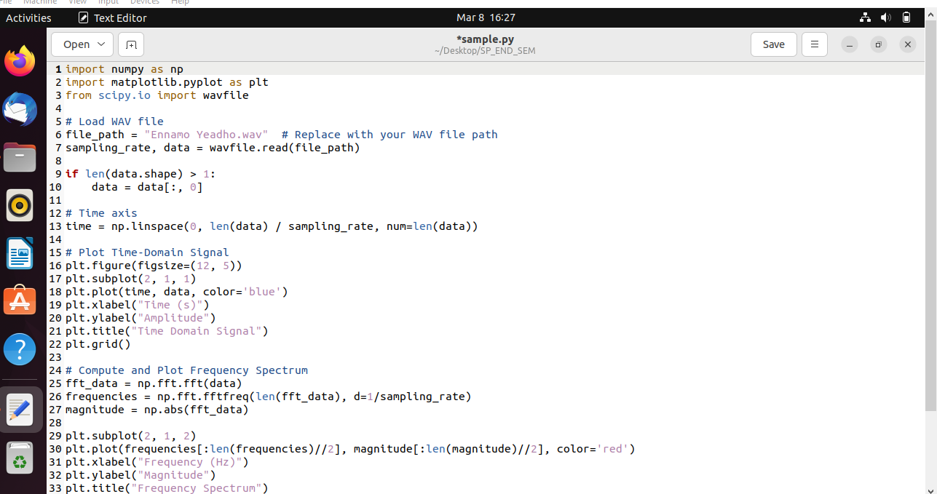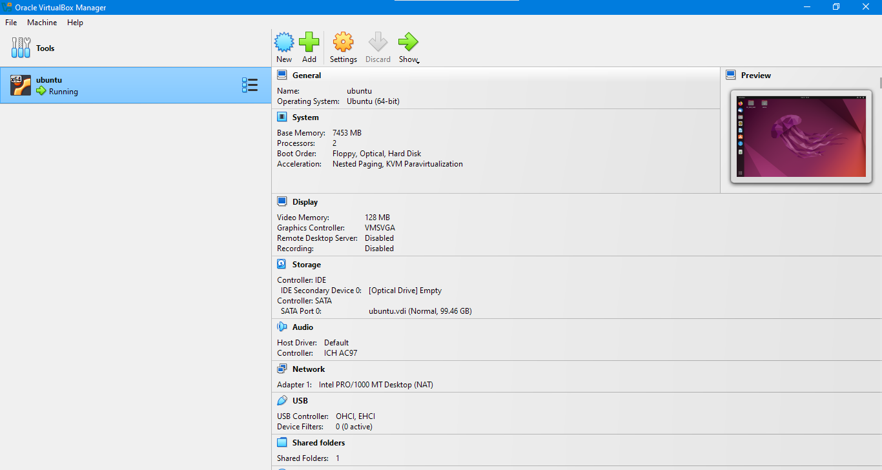**Proofs :**

